|  |  |
| --- | --- |
| No. of Pages | **3**  A |
| No. of Questions | **3** |

**Department of Computer Science and Engineering**

**MIDTERM EXAMINATION SPRING 2015**

**CSE421: Computer Network**

**Total Marks: 45 Time Allowed: 55 minutes**



* Answer ALL **THREE (3)** questions
* Figure in bracket [] next to each question indicates marks for that question



**Question 1**

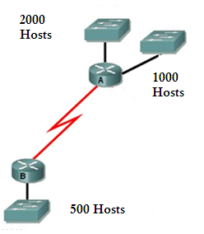

**Figure no. 1**

1. Suppose a company is given a block **200.20.96.0/20.** But you need three more sub networks for your organization and one more for the WAN Link as shown in figure no. 1. Show how you can have 4 more subnets out of the original network address as per host requirements. Do not forget to show basic calculations. [7 marks]

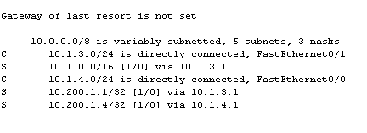

**Figure no. 2**

1. A routing table is shown in the above figure no. 2. Is there any recursive lookup and how can we avoid it? [4 marks]
2. The RIP routing protocol has found a route to network 192.168.7.0/24 through serial 0/0 but there is also a static route to the same network through serial 0/1. Which route will be preferred and placed in the routing table and how will the router decide? [4 marks]

**Question 2**

1. Distance vector routing protocols have a slower convergence, why? [3 marks]
2. Router R1 is running RIPv2 shown in figure no. 3. Summarize the following networks shown at R1 so that R1 can advertise only one summarized network in its updates instead of the 8 separate networks to Router R2. Show calculations. [4 marks]

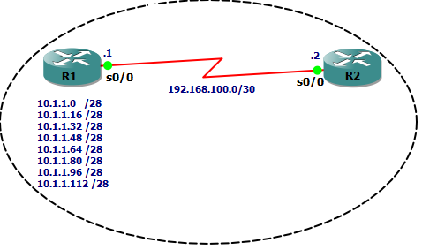

**Figure no. 3**

1. Explain how Split Horizon with Poison Reverse is used in avoiding loops? [4 marks]

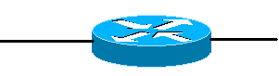

**Figure no. 4**

192.168.7.1

Fa0/0

1. You want the 192.168.7.0 network to be advertised in routing updates, but you do not want routing updates to be sent out of interface 192.168.7.1. Which commands should you give and in which sequence? [4 marks]

**Question 3**

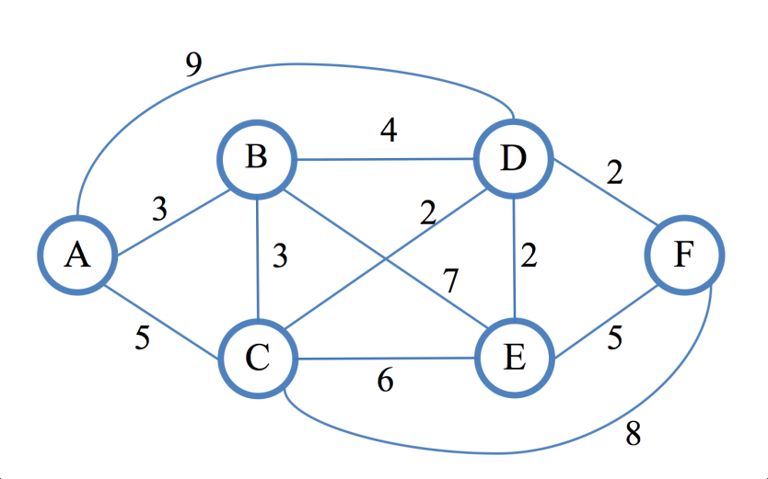

**Figure no. 5**

1. Link state routing protocol uses Dijkstra’s algorithm. Now using Dijkstra’s algorithm, compute the shortest path from Fto all other remote networks shown in figure no.5. Use the table provided. [5 marks]

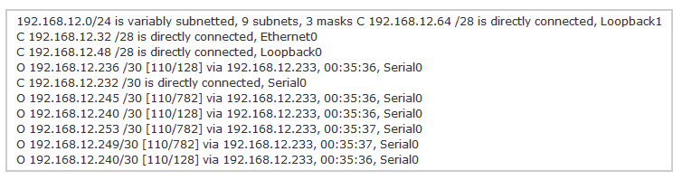

**Figure no. 6**

1. How are the value 128 calculated? [2 marks]
2. What is the difference between Hello packets and Link state packets in OSPF routing protocol? [3 marks]

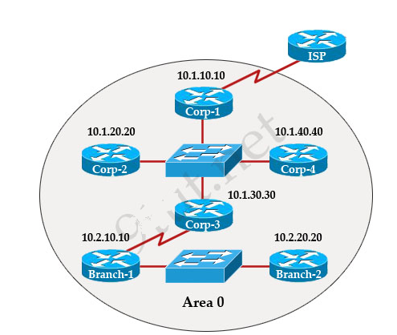

**Figure no. 7**

1. In the above figure no. all routers are running ospf routing protocol. In the above scenario where would the DR and BDR selections will be necessary and which routers are the DRs and BDRs? [5 marks]

**Figure no. 7**

**THE END**